Recycling

- What is Waste?
  - Waste is anything that we throw away that doesn’t get used.
  - Things that might get thrown away everyday include:
    - Food wrappers.
    - Empty water bottles or soda cans.
    - Paper products like old homework assignments.
    - Plastic bags.
    - Spoiled food, extra food, or food peels (like bananas and oranges).
    - Old phones and other electronics.

- Where does all this waste go?
  - Items that are thrown away are picked up and taken to the landfill.
    - A landfill is essentially a big pile of garbage.
  - It takes garbage in the landfill hundreds if not thousands of years to break down.
    - During this breakdown, decaying material can pollute the surrounding land and water, as well as harm wildlife and plants.

- How can we help stop landfills from growing?
  - Reduce, Reuse, Recycle! Lots of things we use every day can be kept out of the landfill by following each of the 3 R’s:

    - Reduce – the best thing you can do is use less. Some examples of reducing your waste include:
      - Consider buying slightly used items before making a new purchase; you can find really cool things at thrift stores, or maybe even get them for free from friends or family
      - Buy new items only when you really need them
      - Bring reusable grocery bags to the store instead of using plastic or paper
      - During meals, take only food that you will eat to prevent extra from getting thrown away

    - Reuse – carry items that can be reused. Before you throw something away, consider if there are others ways you can use it
      - Carry around a reusable water bottle and refill it at the sink or refill station
      - Bring your lunch and snacks in a reusable lunch box instead of a brown paper bag
      - Instead of throwing away paper scraps, plastic bottles, or other items, see if you can use them for a new art project
    - Recycle – this involves taking what would be trash and turning it into something completely new
      - Things like plastic water bottles, paper, cardboard, and soda cans can all be recycled in most cities
      - Other items like glass, electronics, and plastic bags can be recycled, though you should check with your city to see where you should take them

      - Fun Recycling Facts:
        - Plastic bottles can be recycled into T-shirts
        - Plastic bags can be recycled into a Frisbee
        - Newspapers can be made into egg cartons
        - Paper can be made into tissues
        - Metal cans can be made into bike and cars parts
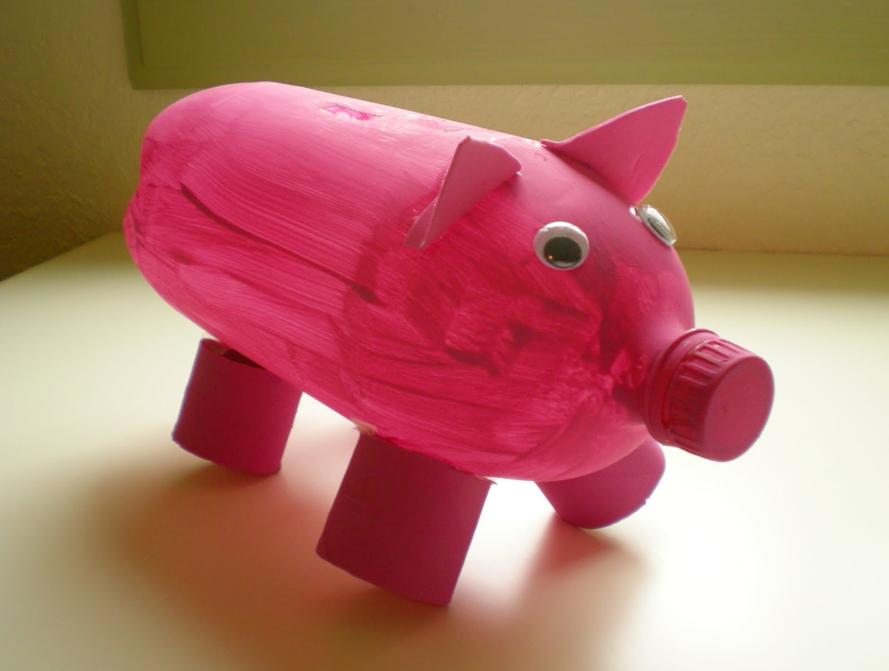
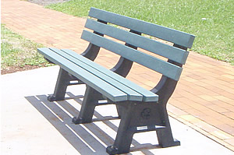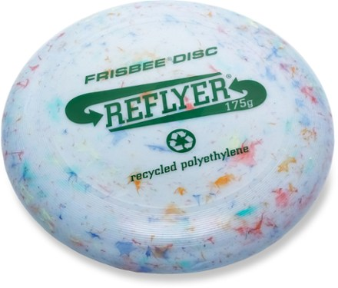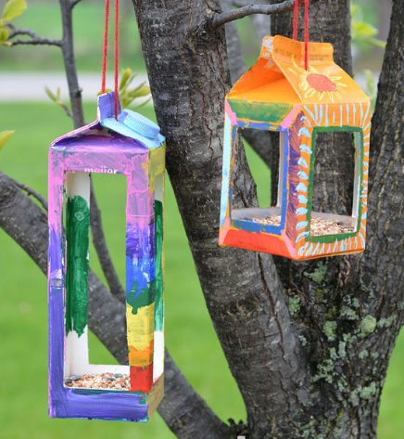
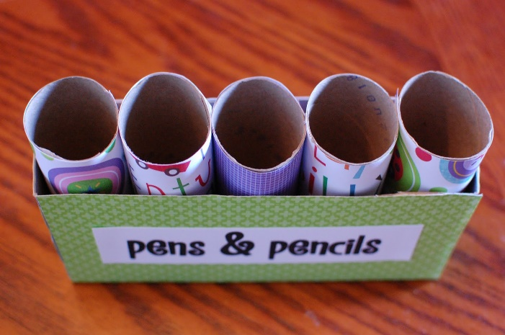

Questions:
What is a benefit of recycling?
    - Recycling reduces pollution
    - Recycling conserves natural resources
    - Recycling saves money
    - All of the above

What are the 3 R’s?
    - Renew, restart, recycle
    - Reduce, reuse, recycle
    - Reduce, redo, Rihanna
    - Reduce, rinse, repeat

What item below helps reduce waste?

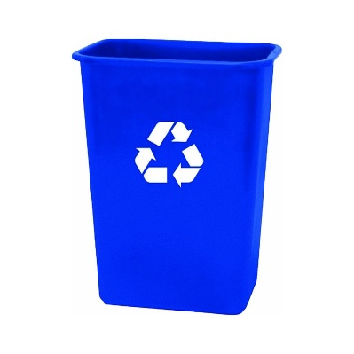
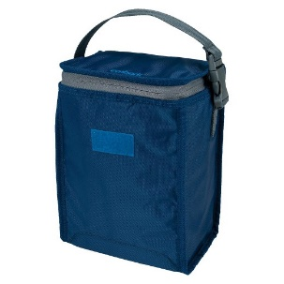
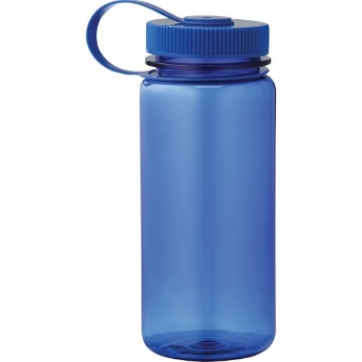
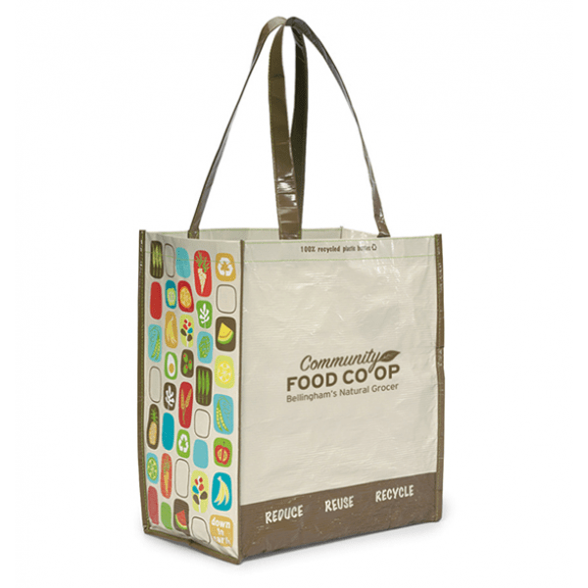

All of them

Which of these cannot be recycled?
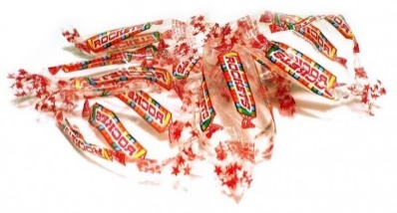
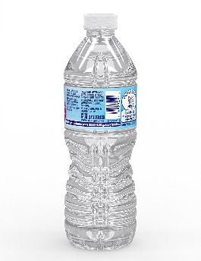
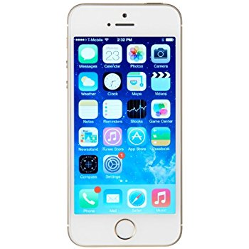

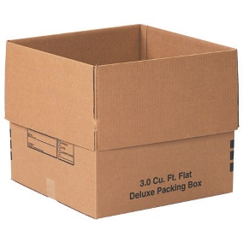
- Candy wrappers

