Energy Saving for Kids!

- What is Energy?
  - Energy comes in many forms like light, heat, sound, motion, and electricity.
  - Energy is something we all use every single day. Some things that use energy that you might have at your house include:
    - Lights
    - TV
    - Refrigerator
    - Oven
    - Cars
    - Bikes

- Where do we get energy?
  - Energy is everywhere! However, that doesn’t mean we can always use it. First we must find a way to capture energy
  - We can capture energy that comes in two forms:
    - Renewable – energy that won’t run out
      - Wind
      - Water
      - Sun
    - Nonrenewable – energy that will run out
      - Oil
      - Coal

- Why should we conserve energy?
    - Energy costs money
      - You may not pay for energy, but your parent’s do!
      - Wasting energy is like wasting money
    - Using energy can be bad for the environment too
      - Using energy, especially nonrenewable energy, creates pollution which is bad for plants, animals, and humans.
    - We always want energy to be there when we need it. This means we should conserve it when we don’t need it!

- How can you conserve energy?
  - Turn off lights and electronics when you’re not using them.
  - Ride your bike to school, or take the bus if you can, instead of driving in your car.
  - Save water by turning off the faucet when you’re brushing your teeth and take shorter showers.
  - Help your parents switch to energy saving light bulbs.
  - Help your friends and family save energy by teaching them what you know!
Questions:

Which of the following use energy?
A.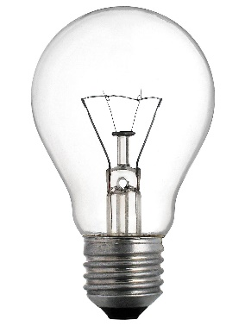B.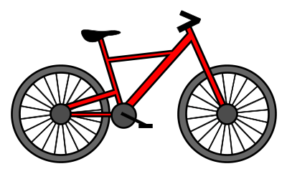C.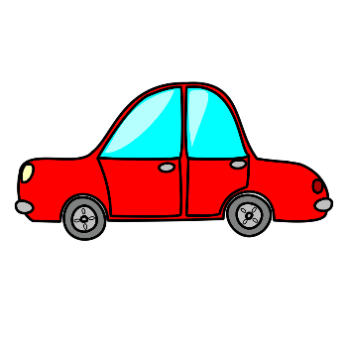
D.E. All of them!
(Answer: E. all)

Which of the following are examples of renewable energy?
- 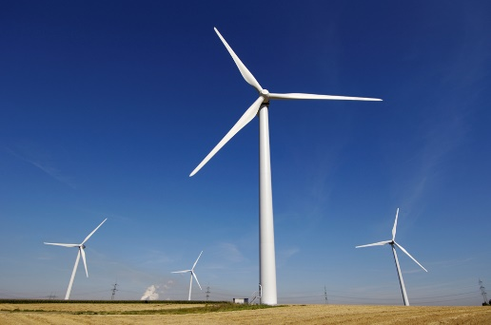 B. 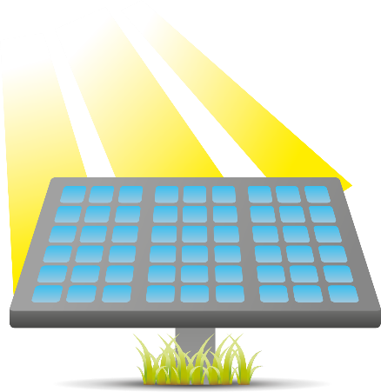
- 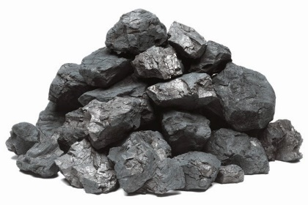D. 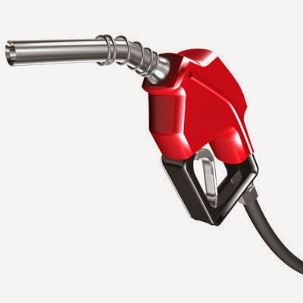

(Answer: A and B)

What of the following are ways you can save energy?
- Turn off the TV when you aren’t using it
- Ride your bike
- Take shorter showers
- All of the above

True or False?
Saving energy can save money!

(Answer: True)

