Renewable Energy

General:
- In the last several years, natural gas has surpassed coal as the greatest source of power generation.
- Currently, the two biggest renewable energy sources are hydroelectric and wind.
Figure 1. 2016 Electricity Generation by Power Source
(Courtesy, US Energy Information Administration, www.eia.gov

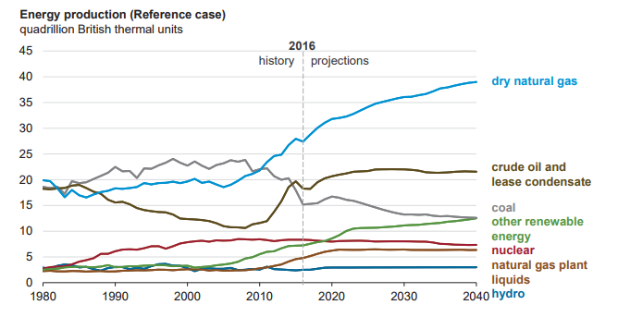

Solar
- General:
  - The sun is our greatest power source.
  - 173,000 terawatts of energy are hitting the earth at any one moment (10,000x the world’s energy use!).
  - Solar panels can help capture this energy and convert it into electricity for us to use.
- Efficiency:
  - Typical solar panels convert ~14% of available energy to electricity.
  - The best solar panels convert up to 22%.
    - Efficiency is improving every year!
  - Typical lifespan of solar panels is at least 25 years (energysage.com).
  - Contrary to popular belief, solar panels can still capture energy on cloudy day.
  - The amount of installed solar capacity installed in the last 10 years has smashed 2006 goals by 4813%!
  - They are even beginning to make solar panel roof shingles to renewably power your home!

Solar Roof via Tesla.com

Ground Source Heat Pumps:
- Ground source heat pumps utilize the relatively constant heat of the Earth (~50 degrees F) to heat and cool homes.
  - How it works:
    - They work by passing fluid (usually water and antifreeze) through a tubing system in the ground.
    - As the fluid passes through the pipes, it either picks up heat from the earth (heating mode) or expels heat into the earth (cooling mode).
    - The fluid then returns to heat or cool the house via a heat exchanger.
- GPHS are typically 25%-50% more efficient than standard home heating/cooling systems (furnace, A/C, electric baseboards) and have substantial emissions reductions.
- Systems last 25 years for in-home components; 50+ years for the ground loop (energy.gov).
Hydroelectric:
- Water is constantly moving around the globe in the form of rivers, oceans, clouds, and precipitation. Capturing energy from the movement of water is a great way to generate renewable electricity. In fact, hydropower is the biggest generator of renewable energy in the US.
  - How it works:
    - Water moving downstream flows through turbines (such as those housed in a dam), causing the turbines to spin, which drives a generator to produce electricity.
    - The reservoir behind the dam acts similar to a battery-- storing the water’s kinetic energy until it is needed. When energy demands are high, water can be released to spin through the turbines to generate electricity.
  - While hydroelectric power doesn’t lead to as much air and water pollution, it can significantly alter the surrounding environment, negatively impacting plants, wildlife, and people living in nearby communities.

Wind:
- Wind energy can be used in a similar scope as solar (to power homes or other small buildings).
  - How it works:
    - Wind drives a turbine which drives a generator which produces electricity.
    - A minimum wind speed of 4-6 mph is needed to reliably produce electricity.
    - Because wind speed increases with height, the taller the turbine the greater wind speed they’ll be able to access. However due to regulations, most turbines can only be 30m tall.
    - Wind energy is highly site specific, as wind speed varies greatly throughout the country (see map).
  - Wind turbines convert about 45% of the wind passing through the blades to electricity (energy.gov).
  - It is one of the lowest priced energy sources today! (energy.gov)
  - Unfortunately wind power can cause disruptions in bird and bat migrations, causing many fatalities every year. Practices are being implemented to help mitigate these fatalities.
Biomass:
- Biomass energy is energy derived from burning plants and other organic materials such as crops, woody plants, algae, and the organic components of municipal and industrial waste.
  - How it works:
    - Biomass can be burned directly as a power source, or converted into a variety of fuels that can be used to power equipment and machinery.
    - Common biomass feedstocks include lumber mill scraps, corn grain (ethanol), and soybeans (biodiesel).
    - This feedstock is converted into power or fuel to be used in a variety of instances.
  - Biomass reduces our dependence on fossil fuels.
  - Because biomass fuels can be made from many different organic products, locations can use whatever feedstock is most readily available.
  - Biomass doesn’t produce carbon emissions and can help reduce industrial waste.

Where we’re heading:
- Renewable energy like solar and wind have become much more economically viable options in the recent decade due to significant advancements in technology.
- According to recent analysis performed by the Natural Resources Defense Council, the US is greatly surpassing the clean energy targets it set in 2006.
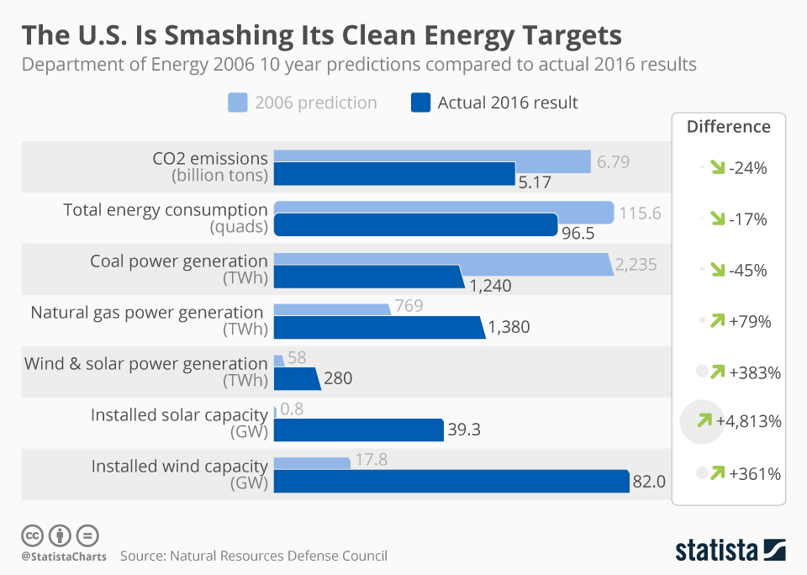

Questions for HS and above
- Renewable energy sources account for what percentage of US energy production?
  - Less than 1%
  - 5-10%
  - 10-15%
  - 20-25%

- What is the current efficiency that can be reached by a typical solar panel?
  - 8%
  - 14%
  - 20%
  - 25%

- Biomass fuels can be made from which of the following feedstocks?
  - Lumber mill scraps
  - Corn grains
  - Soybeans
  - All of the above

- What is the minimum wind speed needed for a windmill to produce reliable electricity?
  - 1-2mph
  - 4-6mph
  - 8-10mph
  - 10-12mph

- Which of the following are benefits of a ground source heat pump?
  - They are 25-50% more efficient than existing home heating systems
  - GSHPs release significantly less emissions than typical home heating systems
  - A and B
  - None of the above

- What are the two biggest sources of renewable energy
  - Solar and wind
  - Wind and hydro
  - Biomass and hydro
  - None of the above

