Home Energy Savings:

- Energy efficient windows
  - Windows are rated for efficiency based on their thermal transmittance (noted as the U-value).
  - Characteristics of EE windows includes:
    - Double or triple pane.
      - Can be filled with a gas, such as Argon, to decrease the thermal transmittance (retain more heat).
    - Low- E coating: a coating that helps reflect heat back into the house in the winter and sunlight back to the outside in the summer.

- Insulation
  - Home insulation levels are rated based on their thermal resistance (noted as the R-value; this is the opposite of U-value).
  - Appropriate levels of insulation depend on the area of the country one lives in (see map).
  - The R-value provided is dependent on the type of insulation as well the heating type of the home (furnace, electric baseboards, etc.).
    - Common types of insulation include:
      - Loose fill fiberglass
      - Fiberglass bats
      - Spray foam insulation
      - Cellulose (blown-in or spray)

- Lighting:
  - Here’s a quick comparison of lighting types:

  - Incandescent:
    - This is the standard Edison bulb with the glowing filament.
    - 90% of the energy consumed by incandescent bulbs is actually given off as heat!
    - Typically only last 3-4 years.
    - Cost less initially, but because they must be replaced more often, they end up costing more in the end.

  - CFLs (Compact Fluorescent Lighting):
    - CFLs are a form of efficient lighting.
    - CFLs use 75-80% less energy than incandescent bulbs.
    - They are typically cheaper than LEDs, though they don’t last quite as long.
    - Come in all shapes, sizes, and color temperatures.
    - Don’t work as well in cold weather (need to heat up to full brightness).
    - Wear out quicker when turned on and off frequently.
    - Contain mercury gas, which must be disposed of properly when broken or at the end of lifespan (check with local recycling guidelines).

  - LEDs (Light Emitting Diode):
    - LEDs are the most efficient form of lighting on the market today.
    - LEDs produce little to no heat, meaning the majority of the energy they consume is given off as light (what we want!).
    - LEDs also last much longer (8-10 years under typical use) and come in all shapes and sizes.

- Water efficiency
  - Quick, low cost installations:
    - Converting to low flow shower heads on average saves 1 gallon/minute/shower.
    - Sink aerators in the kitchen and bathroom reduce water flow while still maintaining pressure. They save on average 1 gallon/minute.
    - Efficient toilets use as little as 0.8 gallons per flush, though 1.28 gallons/flush is most common:
      - Converting a post-1992 toilet to an efficient toilet saves 1/3 -1/2 gallon per flush.
      - Converting from a pre-1992 toilet can save anywhere from 2.2-6 gallons per flush (depending on the age of the toilet).
    - Look for the WaterSense label to know you’re getting an efficient fixture.
    - Consider xeriscaping your yard (less grass, more native plants that are suited to the environment, rocks).

- Energy efficiency:
  - Buy energy efficient appliances (Energy Star rated).
  - Insulate water heater and pipes (saves 7%-16% of energy bill/year).
  - Install a programmable thermostat.

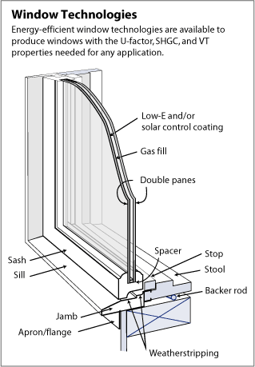
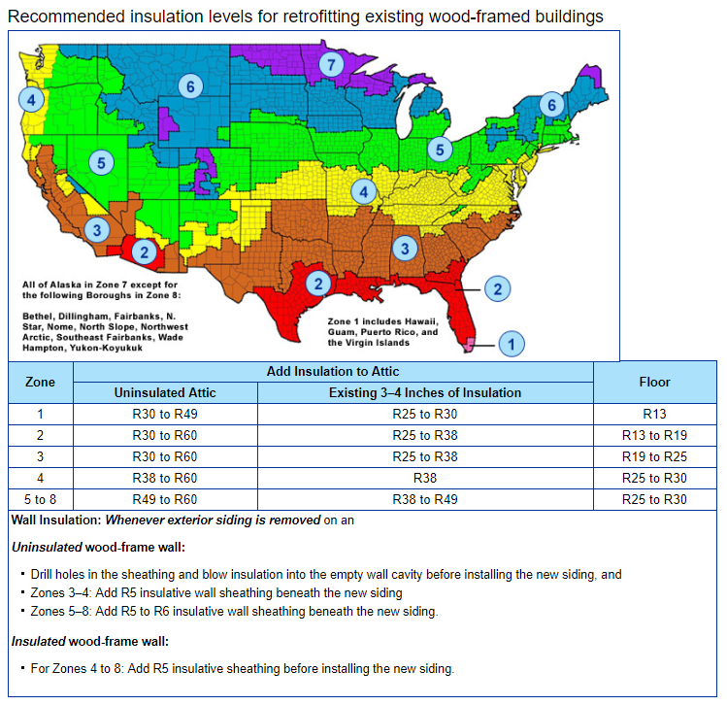

(Energy.gov)

Questions for HS and older:
- Why are LED light bulbs the most efficient?
  - They generate little to no heat, meaning the majority of energy they consume is given off as JUST light
  - They last longer
  - They contain mercury gas which extends their life span
  - Both A and B

- What installations can be made in a home to reduce water use?
  - Low-flow toilets
  - Low-flow showerheads
  - Sink aerators
  - All of the above

- What combination represents the most efficient type of window?
  - Single-pane window
  - Double-pane window
  - Double-pane window with low-e coating
  - Double-pane window with low-e coating and a gas fill

- What is the term used for a yard that utilizes native plants and rocks instead of typical green grass?
  - Desertiscaping
  - Xeriscaping
  - Rock gardening
  - Ungrassification

- What device can you install in your house that controls temperature based off predetermined time settings?
  - HVAC system
  - Programmable thermostat
  - Thermometer
  - Ventilator

